INFORMATION ABOUT EGYPT
WHY WERE THE PYRAMIDS BUILT?
The belief in life after death was behind the reason for pyramid building.
Egyptians believed the spirit could remain alive after death if the body was preserved and provided with all the things needed for its survival. The dead kings were therefore provided with a tomb pyramid to achieve this. They were buried with vast treasures as well as the ordinary day to day requirements of life.
Ancient Egyptians believed that life after death was an idealised version of our world. This ‘heaven’ was called the Field of Reeds, a group of islands reached by a magic boat. (Boats were often buried with the dead). The Greeks followed this idea by calling their heaven the Elysian Fields.
THE INFLUENCE OF RELIGION
The development of the official religion began in the Pyramid Age. The Egyptians believed in sun worship and according to legend, the sun god first revealed himself in the form of a phoenix. The phoenix was a mythical bird of brilliant gold and reddish purple feathers. After living for 500 years it was supposed to burn itself on a funeral pyre and rise again from the ashes – a symbol of immortality.
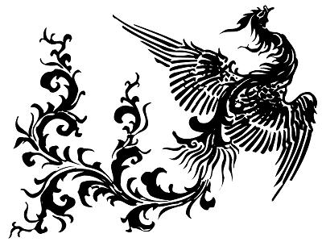
Egyptians believed their god Ra was reborn each day at sunrise and crossed the sky in a boat – a classic example of survival beyond death. Eventually the Kings or Pharaohs became identified as the sons of Ra and at their deaths they accompanied the sun god Ra across the sky.
MAGIC SPELLS
The steps or shape of the pyramid were to help the spirit of the king ascend to heaven. Some inscriptions written on the inside walls of the burial chamber were known as spells. Ancient Egyptians firmly believed in the magic power of the written word – with the correct formulas you could produce a magic spell. One such spell refers to the pyramid as….
“a staircase to heaven is laid for the king. So he will mount up to heaven thereby…”

There is a temptation to believe that the sun was so important that the shape of the pyramid could represent the sun’s rays. Another spell says…
“Heaven hath strengthened for thee the rays of the sun In order that thou mayest lift thyself to heaven As the eye of Ra…”
An interesting point about the Egyptian gods is that Amen was the only god in the form of a man. They thought of him as the god who brought life to man. Is this why Christian prayers end with Amen?
EMBALMING OR PRESERVING THE BODY
Egyptians believed that a mummy or preserved body was necessary for the survival of the soul (or Ka).
The embalming process was one of the ceremonies performed in the temples attached to the pyramids. First the intestines were removed and the brain sucked out through the nose. The body cavities were then filled with oils and spices and resins and packed with sawdust. The body was then soaked in a salt solution (natron) which ‘cured’ it like bacon.
The use of pitch and tars often gave the mummies a black appearance.
Finally the body was carefully wrapped in bandages and then placed in a coffin which was often carved in the shape and with the facial features of the dead pharaoh.
In 1880 the mummy of King Merenre was found in his pyramid where it had been perfectly preserved for 4500 years.
WHERE DID THE NAME EGYPT COME FROM?
A famous ancient Greek poet, Homer, (who wrote the two great Greek poems, the Iliad and the Odyssey) gave Egypt its name.
He called the land Algyptos – the land of the Nile Valley and this was later shortened to Egypt.
The Egyptian Civilisation is very important to the understanding of our own history,
Ancient Egypt lasted long enough (one of the longest lasting civilisations) to pass on its culture and knowledge to the Greeks and Romans. They in turn, have passed on a great deal to our own civilisation.

THE SPHINX
One of the most popular tourist attractions in Egypt is the huge Sphinx.
It was built close to the three famous pyramids at Giza. When one of these pyramids was being built for the pharaoh King Khafre, (Chephren), there was a large outcrop of sandstone nearby. The rock outcrop was carved into the shape of a guardian sphinx for the king. The paws however, are made of giant stone blocks.
A sphinx was an imaginary creature of ancient myths. Egyptians, Greeks and people of the Near East had legends about these strange beings. In Ancient Egypt, the Sphinx was supposed to represent the god Horus who guarded temples and tombs and so a sphinx was often placed close to these buildings. Usually the sphinx had the features of the pharaoh it was guarding.
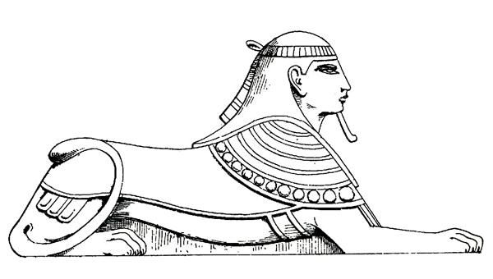
The Great Sphinx at Giza wears a striped royal head cloth and the snake emblem on the forehead also indicates royalty. But although the Sphinx has a human head, the body is that of a lion. Under the paws is an inscription which requests – Move back the encroaching sand. The Romans tried to clear away the sand but it blew back. Unfortunately the nose and features of the Sphinx have been shot away by Arabs using it for target practice.
Egyptians made many statues of the Sphinx. Usually they had the head of a man and the body, legs, feet and tail of a lion. Some statues had heads of rams or hawks.
Egyptians often lined both sides of special roads with sphinx statues.
RIDDLE OF THE SPHINX
In Greek literature the sphinx had the body of a lion but usually had the head of a woman.
A sphinx of the Greek myths lived on a high rock.
If anyone passed by she would ask them a riddle.... “What has one voice – is four footed – two footed and three footed?”
No one knew the answer until King Oedipus came along and gave the correct reply. The Sphinx flew into such a rage that she fell off the cliff and killed herself.
Do you know the answer? Man. As a child he crawls on four feet, then he walks on two feet and as an old man he needs a cane to walk with.

QUESTIONS FOR RESEARCH:
- What does ‘embalming’ mean?
- Why were pharaohs’ bodies preserved?
- Why were the pharaohs’ bodies placed in a pyramid structure?
- What other forms of burial were practised by the Egyptian people?
- For ordinary people
- For important people
- What was the purpose of the spells contained in the “Book of the Dead”?
- What sort of burial procedures and ceremonies does our society observe today?
- For ordinary people
- For important people

